**MIS 6308 SYSTEM ANALYSIS AND PROJECT MANAGEMENT**

**Group 6**

**Shreenidhi Sriram - sxs200264**

**Prarthana Barangule - pxb210017**

**Ria Jain - rvj200000**

**Gunjan Mishra - gxm210015**

**Praveen Sivakumar - pxs210042**

**Keyuri Bhuwariya - ksb210003**

**STUDENT ASSISTANT SYSTEM**

**Overall Goal**

As college students, we have noticed that some students miss deadlines or start working on projects/assignments/on-campus job applications too late and then may face issues with technologies or may have questions or are working till the last minute to meet a submission/application deadline. This causes unnecessary stress to students which can be avoided by starting early. We wanted to create an application that would help in notifying the students of meeting deadlines for such tasks. This would help to make a student’s life easier by solving a common issue that is faced by students.

This project would create a student assistant application that would provide notifications to remind a student to work on assignments, apply for jobs, register for courses, and submission before deadlines with a robust user interface.

This project would be an educational experience as we would be able to demonstrate the application of UML analysis, design, and implementation techniques.

**Scope**

The main purpose of the design is to make all critical student information under a single umbrella.

* The major components of the system include:  
  **HTML 5 & CSS** - used for creating the webpages like homepage, login page,etc.  
  **Java** - used in the backend version: JVM 15.0.3   
  **Database**: MySQL for storing user information.  
  **Version control**: Github.
* The application would be enabled for all operating systems – Android, IOS

Out of Scope

Activities like Academic holds, payment options, and job applications are out of scope. This student assistant is a simple tool to notify the user. It fetches data like time and new incoming emails.

**System Capabilities**

The system will be capable of:

1. Students must manually enter their information or upload the syllabus to obtain the dates and other information in order to utilize Google Calendar or a calendar that is linked to the application.

2. Account sign-in will be the same as the Google account.

3. Include the fact that the app is ad-free, permits file attachments, and has access to external calendars.

4. It is a cross-platform app, so you may use it on a Mac, Windows, Android, iPhone, or iPad.

5. The "Contact Options" header allows the student to choose the email address and mobile phone number to which notifications should be delivered through SMS.

6. When a student uploads their syllabus and the academic calendar, the application automatically retrieves the information and notifies the users of forthcoming due dates for assignments, quizzes, and exams.

7. System of Recommendations for Grade Estimator: Students can also determine their estimated GPA by entering the grades they received on their assignments and tests.

8. One week before your exam, you'll receive a notification about booking test dates and times.

9. Students will also be notified via this application when certain courses are no longer on the waitlist or are available for registration for the semester, allowing them to select and sign up for the courses they want to take.

10. The user will receive a pop-up notification each time a new on-campus job posting is made so they may promptly submit their application through the preferred portal.

**System Design**

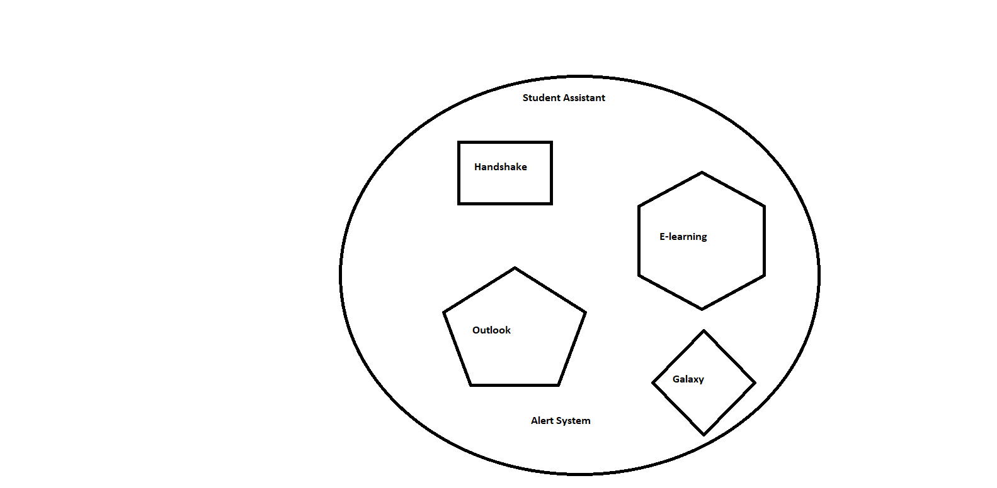

**Fig 1.0 Simplified representation**

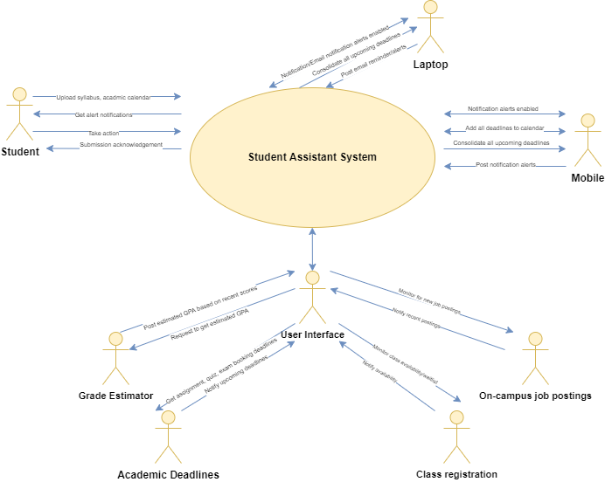

**Fig 2.0 Overall context diagram**